OFFICIAL COORDINATION REQUEST FOR
NON-ROUTINE OPERATIONS AND MAINTENANCE

COORDINATION TITLE-14BON77 UI testing request
COORDINATION DATE- 08 October 2014
PROJECT- Bonneville Dam fishways, Washington shore NDE and BI serpentine section.
RESPONSE DATE- 23 October 2014 (or at the 09 October FPOM)

Description of the problem – The operation of the BON Lamprey Flume System (LFS) has been hindered by entrained air in the water supply. Operation at higher flow rates has resulted in a potential “bubble curtain” at the NDE fishway entrance, preventing operations at higher LFS flow rates. Additionally, collection rates of adult lamprey in both 2013 and 2014 were relatively high in the early season and then dropped to much lower levels later, suggesting the potential for an influence of tailwater elevation on LFS collection rate (Figure 1). Low attraction flow from the LFS, bubbles, and/or hydraulic conditions near the LFS entrances such as NDE eddy countercurrents may be impeding attraction and guidance into the structure. CFD modeling conducted as part of the LFS design process suggests flows from the LFS project out to the tailrace somewhat more effectively at high compared to low tailwater elevations.
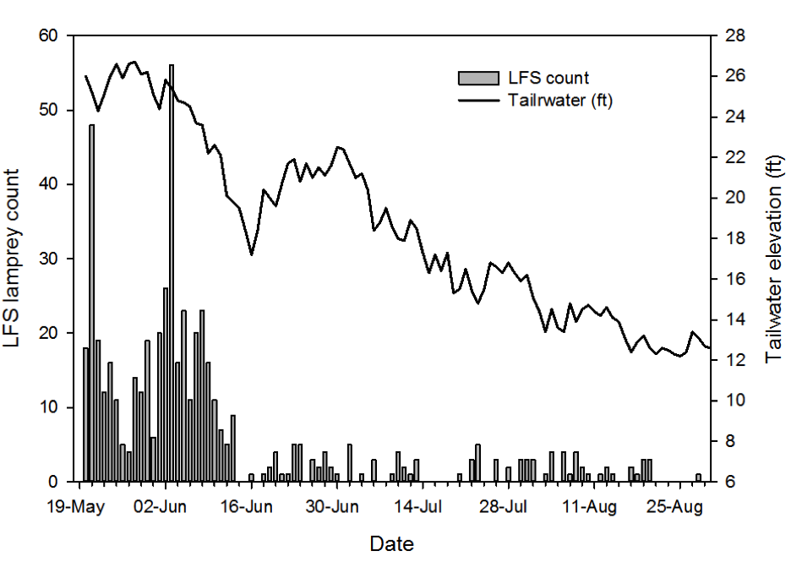
Figure 1: Daily lamprey collection at BON NDE LFS (bars) and BON tailrace elevation, 2014.

In an effort to diagnose mechanism(s) affecting lamprey use of the LFS and to detrmine acceptable operating conditions, the University of Idaho will conduct dual-frequency identification sonar (DIDSON) and acoustic Doppler current profile (ADCP) measurements at NDE. DIDSON observations will focus on determinng the location and extent of bubble flow out of the upper and lower LFS entrances at varying flow settings. Flow to the upper LFS entrance can be shut off and thus the effects of shunting all LFS flow to the lower entrance on bubble flow can be evaluated (Table 1). The test will be conducted under normal daytime operations and reduced nighttime lamprey operations.

Table 1: Proposed schedule of observations for ADCP and DIDSON at BON NDE.
Measurement | LFS Settings | Upper Entrance Valve | Lower Entrance Valve | NDE Entrance Velocity
ADCP | 70% | Open | Open | 8 fps (daytime op)
ADCP | 70% | Open | Open | 4 fps (nighttime op)
DIDSON | 0,40,50,60,70, and 80% | Open | Open | 4 fps (nighttime op)
DIDSON | 0,40,50,60,70, and 80% | Closed | Open | 4 pfs (nighttime op)

Both instruments would be deployed from the existing I-beam downstream of NDE previously used for DIDSON observations. Observations would be made while varying LFS operational conditions as identified in Table 1.

Multiple ADCP transects will be used to map flow conditions at the NDE entrance, in the vicinity of the LFS transects and the plume area immediately downstream. ADCP transects will be made looking eastward toward NDE (upstream), southward (across-flow) and westward (downstream). The ADCP will be unable to image within ~1m of substrate, but will provide data on flow conditions above the lower LFS entrance and downstream from the upper LFS entrance, and on the size, magnitude and location of any recirculation eddy. ADCP observations would be made during reduced nighttime (lamprey) operational conditions at NDE and at normal daytime conditions. Reduction of flows at NDE during daytime would facilitate deployment of equipment and provide a safer work environment.

DIDSON observations will determine the source of bubbles (upper and/or lower LFS entrances), lateral distribution of bubbles, and extent of bubbles in relation to the NDE fishway entrance slot at LFS valve openings (-flow rates) or 0, 40, 50, 60, 70, and 80%. Observations at each setting will not exceed 15 minutes, particularly since valve settings >80% produce maximum flow and we expect high entrainment air at these settings. Pending results, additional requests for access may be made for observations during higher tailwater conditions during spring 2015.

As part of the USACE Portland District research, UI deployed video cameras in the Bradford Island Fishway serpentine weir section to collect data on Pacific lamprey passage during July 2014. The deployments occurred for two weeks and data is being reviewed. Image quality is high and a large number of events are present in the video. Behavioral observations made in the video to in situ hydraulic conditions in the serpentine weirs may be linked to experimental flume studies conducted in the BON AFF flume during 2013-2014. Access will be requested to the B1 Serpentine Weir location during an approximately 1 week period during January to conduct hydraulic measurements using an Acoustic Doppler Velocimeter (AVD). The I-beam would be deployed up- and downstream of weir slot 5 in preexisting slots. The ADV would be mounted on the I-beam on a cross area similar to those used for cameras and lights during summer 2014. The cross arm will be longer to allow measurements across the width of the slot. The ADV probe and cross-beam will be approximately 3” diameter.

Type of outage required- No complete outage but a request for reduced night time flows at WA NDE which ended August 31 (see Impact on facility operation).

Impact on facility operation- Continue to reduce night time velocities at Washington shore NDE from 8 fps to 4 fps. These operations ended August 31, they would need to be restored during NDE measurements of velocity and bubble curtain. Also, reduction of flows at NDE during daytime would facilitate deployment of equipment and provide a safer work environment.

Dates of impacts/repairs
- ADV BI serpentine section velocity -November 2014
- DIDSON WA NDE bubble curtain -November 2014
- ADCP WA NDE - January 2015

Length of time for repairs
- ADV 1 week at BI serpentine section
- DIDSON 1-2 days at WA NDE
- ADCP 1-2 days at WA NDE

Expected impacts on fish passage
Fish passage is typically very minimal during November and January at both Washington shore and Bradford Island ladders (see figures below). This work will involve lowering gear into the fishways on existing I-beams or slots. The size of the gear will not occlude fish passage but has a small potential to cause some delay. Because this work has been timed to coincide with the end of most fish passage, impacts are expected to be minimal.

The daytime ADCP measurements will require running the LFS at 70% open, which will likely cause entrained air and generate bubbles. Tailwater elevations in early November the previous two years ranged from 9 to 12 ft. In late November they ranged from ~12 to 17 ft. The test will last no longer than 1 hour to minimize fish impacts. The daytime ADCP testing is necessary to accurately pattern the LFS bubble pattern during normal fishway operation.

Bradford Island is scheduled to be out of service from 10-23 November for road work and FV 3-7 inspection (see MOC 14BON21). That would leave Washington shore and Cascade Island as the active ladders (five entrances). In 2013 this was also a time of very low fish passage.

Figure 1. Annual trends in salmonid passage at Bonneville Dam, 10 year mean (both ladders).

Figure 2. Fish passage at Bonneville’s Washington shore ladder in November 2013 from USACE. Chinook and Coho are the upper lines.

Figure 3. Fish passage at Bonneville’s Bradford Island ladder in November 2013 from USACE. Chinook and Coho are the upper lines.

Figure 4. Fish passage at Bonneville’s Washington shore ladder in January 2012 (Cascade Island was used in 2013) from USACE. Notice the change in y-axis.

Comments from agencies

Final results

Please email or call with questions or concerns.
Thank you,
Scott Fielding

Scott Fielding
PM-E bio
509-527-7236
Scott.D.Fielding@usace.army.mil

Tammy Mackey
NWP Operations Division Fishery Section
Columbia River Coordination Biologist
503-961-5733
Tammy.m.mackey@usace.army.mil

